Dear Parent or Guardian:

Access to Computers and the internet and the ability to effectively use this technology are becoming increasing important for all students. Internet service will allow students search for information, assist in homework completion, and access to education programs such as iXL.

That is why we are excited to let you know about a new program provided by Comcast called Internet Essentials.

This is internet service to your home for $9.95 per month. There are no price increases, no equipment rental fees, and no activation fees.

In addition to that Comcast is offering a low cost computer for $149.99 and free internet training. The training can be online, in print, and in person.

If you are interested in bringing technology in your home you can sign up by calling 1-855-846-8376. You can also visit InternetEssentials .com for more information.

To qualify:
- At least one child on free and reduced lunch.
- No outstanding bill with Comcast
- You have not had Comcast Internet within the last 90 days

Again we want all students to have access to online learning and we think this is an opportunity to enhance your child’s educational experience.

Please complete the form on the back and return to your child’s teacher.

Sincerely,
Joy Fofana
School Counselor

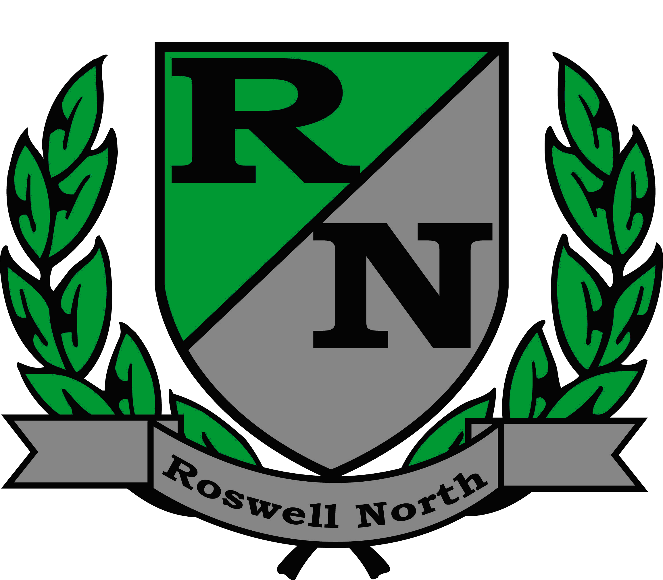

I will take advantage of the full offer from Comcast and purchase a new computer for $149.99. Internet can be purchased at any time. Please return this form and get information on educational programs and upcoming free trainings.

I have a computer and internet service. I would not be interested in this offer. Please return this form and get information on educational programs and upcoming free trainings.

I currently do not have a computer in my home and would like assistance purchasing a refurbished desk top or laptop. Please return this form for assistance and to receive information on educational programs and upcoming trainings.

Name_____________________Phone______________________

Address_______________________Email____________________

Student receiving free/reduced lunch_________________________
Student’s Homeroom_____________
Grade_____
Have you purchased Comcast Internet______

If you need assistance signing up with Comcast Internet Essentials please contact
Joy Fofana at fofana@fultonschools.org or 770-552-6320 ext 129

Please return forms to your child’s teacher.

